Staff Report
Meeting Date: December 8, 2020
To: Siskiyou County Board of Supervisors
From: Kirk Skierski, Planning Director
Subject: Old Highway 99 Road Abandonment Project (RA2001)

Project Description
Siskiyou County Public Works is requesting approval for the Old Highway 99 Road Abandonment project (RA2001) to vacate certain portions of right of way along Old 99 Highway, County Road 5K05, containing 1.23 acres more or less, shown as Area “B” on Siskiyou County Hanging Map 16560-1 (Exhibit A). Figure-1 below provides a general visualization of the proposed Road Abandonment project and Figure-2 below shows the project location.
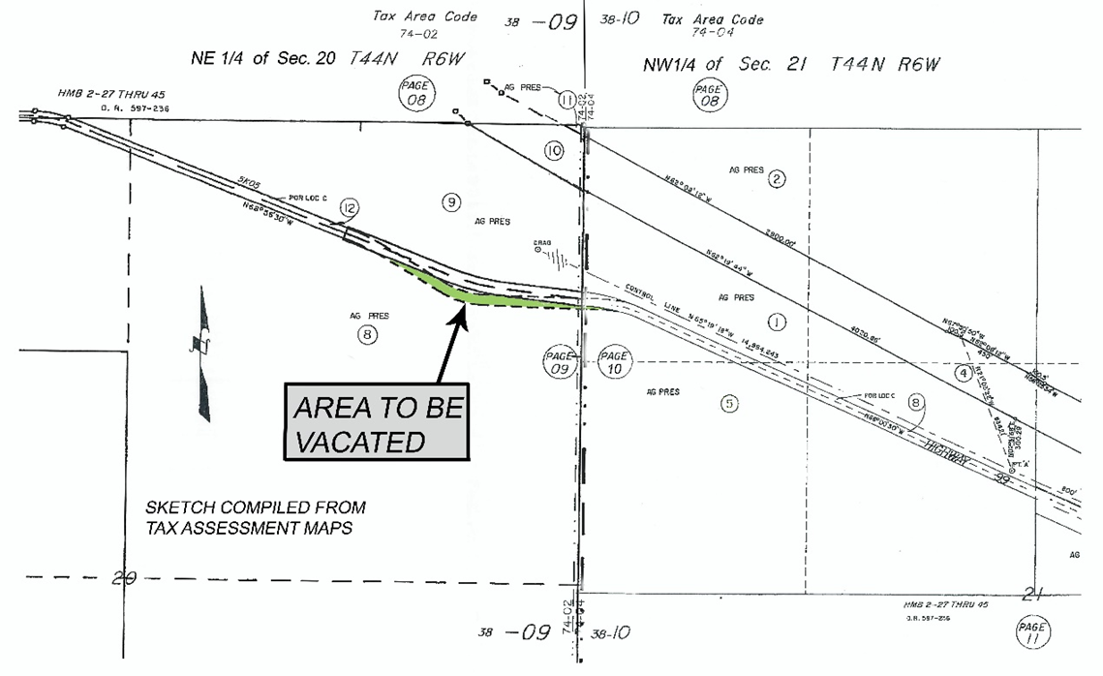
The project site is located adjacent to and running parallel with Old 99 Highway, West of the community of Grenada on APN 038-090-120; Township 44N, Range 6W, Sections 20 & 21 MDBM; Latitude 41.652°, Latitude -122.557°. The portions of right-of-way to be vacated were superseded as part of a Highway Safety Improvement Project, which realigned approximately 0.43 miles of roadway, and are no longer necessary for highway purposes. The project is situated in both Prime Agriculture (AG1), and Non-Prime Agriculture, 40-acre minimum parcel size (AG-2-B-40) zoning, and was previously utilized exclusively for highway purposes.
Figure-1

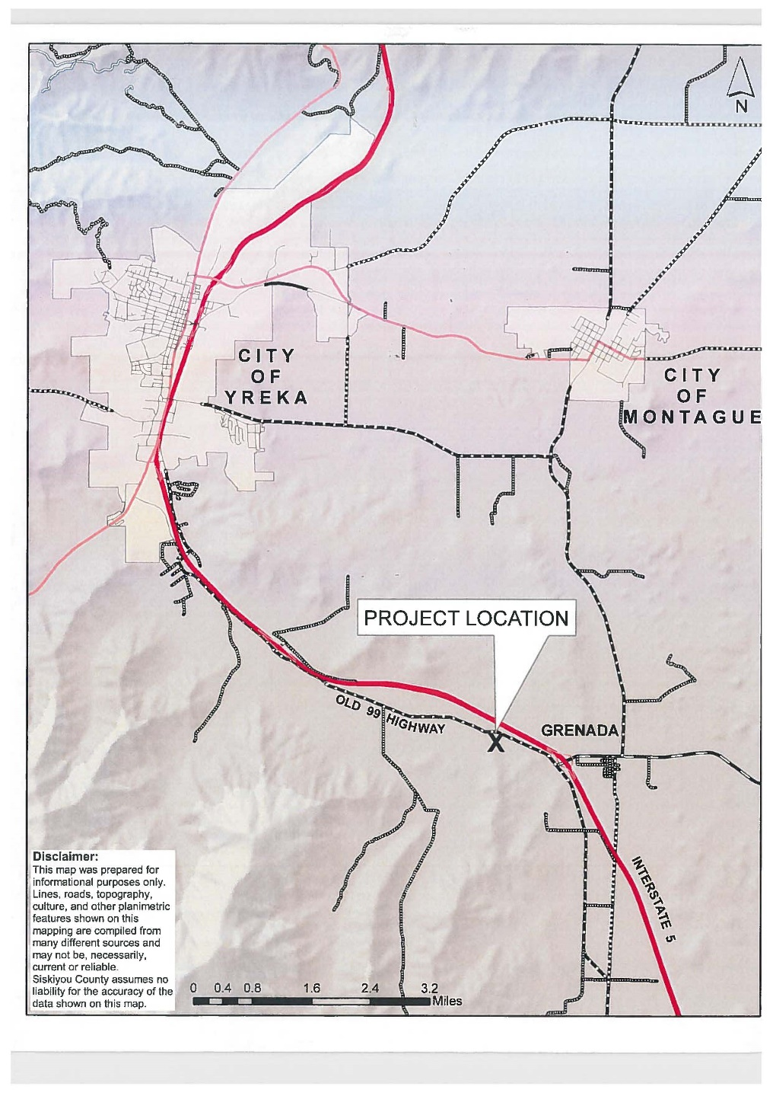
Background
Figure-2 Project Location Map
In 1919, the State of California obtained the following sixty foot (60’) wide rights of way to facilitate construction of this portion of roadway, known as U.S. Route 99:
1.) Book of Deeds 100, Page 497, recorded on September 12th, 1919.
2.) Book of Deeds 100, Page 505, recorded on September 15th, 1919.
This alignment served as State Highway 99 for approximately 50 years, until it was superseded by the construction of the Interstate 5 Freeway in the early 1970’s. This portion of highway was relinquished by the State of California to the County of Siskiyou by agreement dated December 14th, 1965, and January 24th, 1967, recorded on July 23rd, 1970 (Official Records, Volume 597, Page 236). It was accepted into the County Road System by way of Board Resolution 3-230, dated August 12th, 1970. This portion of highway is depicted as “Location C” on Highway Map Book 2, Pages 40 thru 44. Public Works has interpreted the right-of-way obtained in 1919 to be an easement for highway purposes, meaning the current adjacent land owner holds title to the underlying land.
In late 2010, Public Works began preliminary engineering activities in order to facilitate a bridge replacement and road realignment project along Old 99 Highway. The purpose of this project was twofold,
1.) Replace a deteriorated bridge structure; and
2.) Enhance traffic safety by realigning the roadway.
This project included an alignment that shifted the roadway approximately 80’ feet to the north and utilized larger radius curves. This realignment necessitated the need to purchase an additional right-of-way easement containing 2.75 acres. A portion of this easement, containing 1.95 acres, was encumbered by a Williamson Act agriculture preserve contract.
Pursuant to Government Code Section 51292 (Williamson Act), the Planning Department reviewed the proposed acquisition and issued a staff memo in support of the required findings, which were adopted by the Board of Supervisors (Resolution 16-112).
A contract of acquisition was executed between Siskiyou County and John and Kathryn Brazie, which stipulated that the superseded right-of-way would be returned to natural soils and that the County’s rights to this property would be transferred upon completion of construction of the new roadway. Additionally, the County would assume all responsibility for any Williamson Act requirements, including transferring the acreage into the Brazie Williamson Act contract (Official Records, Volume 808, Page 1).
On July 8th, 2016, the necessary right-of-way easement containing approximately 2.75 acres was acquired along the new roadway alignment (Document No. 2016-0006670-00), resulting in 1.95 acres being removed from the agriculture preserve.
On July 18th, 2017, the Board of Supervisors approved the award of Contract No. 16-07, Guys Gulch Road Realignment, Guys Gulch Bridge and Approaches, and Schulmeyer Gulch Bridge and Approaches.
On June 28th, 2019, construction of Contract No. 16-07 was completed, including returning the superseded right-of-way back to natural soils. A Notice of Completion was approved by the Board of Supervisors on November 12th, 2019 (Document No. 2019-0009534-00). The remaining work to be completed includes vacating the right-of-way, which is before the Board for review and action, and adding that acreage to the Brazie Williamson Act agriculture preserve contract, which would be completed after the Road Abandonment project has been approved.

Discussion
The law governing road abandonments, also known as vacations, is located in California Streets and Highways Code Sections 8300-8363, specifically within Part 3., Public Streets, Highways, and Service Easements Vacations Law. When reviewing road abandonment requests, Streets and Highways Code requires the legislative body of a planning agency to consider and report on the General Plan and potential pedestrian or public use impacts, which is incorporated into this staff report along with the Recommended Findings contained within Attachment #1 for the Draft Resolution. The discussion of this staff report and the discussion contained in the Recommended Findings (Exhibit B) provides further detail on the project’s consistency with the Streets and Highways Code, including the required findings, and consistency with the Siskiyou County General Plan.
Streets and Highways Code Consistency
Streets and Highways Code requires that road abandonments be made under Section 8335 of Article 2 in Chapter 4, Part 3 of Division 9 of the Streets and Highways Code, which requires the Board of Supervisors to make the following findings:
- That the vacation is made under this chapter;
- The name or other designation of the street and a precise description of the portion vacated;
- Facts under which the summary vacation is made, see sub-section below for further details; and
- Identification that from and after the date the resolution is recorded, the street, highway, or public service easement vacated no longer constitutes a street, highway, or public service easement.

Chapter Four (Summary Vacation) of the Public Streets, Highways and Service Easements Vacation Law, beginning at California Streets and Highways Code Section 8330, allows the Board of Supervisors to summarily vacate street easements by adopting a resolution. Excess right-of-way easements that are not required for street or highway purposes are eligible to be summarily vacated. Based upon the facts described within this staff report, the Road Abandonment project (BA2001) may be summarily vacated. Prior to summarily vacating such easements, the Board must adopt a resolution making certain findings, including that the easements are not useful as a non-motorized transportation facility (Streets & Highways Code § 892(a)), and include the facts under which summary vacation is made (Streets & Highways Code § 8335(b)). A resolution summarily vacating the above-described Road Abandonment project, and making the required findings is attached for the consideration of the Board of Supervisors, see Attachment #1 for Draft Resolution, which includes the Recommended Findings (Exhibit B).

Pursuant Sections 8340 and 8341, of the Streets and Highways Code, Siskiyou County is required to reserve and except from the vacation any easement and right necessary to maintain, operate, replace, remove, or renew the public utility facilities. Language reserving these rights must be included in the Board Resolution and may refer to Exhibit A, which depicts the location of said utilities. Exhibit A will be permanently on file at the Siskiyou County Surveyor’s Office as Hanging Map No. 16560-1.

General Plan Consistency
Before the Board of Supervisors may vacate certain portions of Old Highway 99, pursuant to Section 65402 of the Government Code, the Board must first consider and determine whether the vacation conforms to the General Plan. Staff has reviewed the proposed Road Abandonment project and the General Plan and finds that the provisions of the General Plan are not compromised by the vacation and will not negatively impact the intent of any of the policies established in the General Plan nor cause any physical changes to Old Highway 99. The proposed project is the result of a bridge replacement and road realignment project. This project replaced aging infrastructure and improved traffic safety. As a result of the project, a portion of the roadway is no longer necessary for highway purposes. The Circulation Element of the General Plan encourages developing and refining a system of high standard collector and arterial roads that improves traffic safety and reduces travel time within the county. In addition, the surrounding properties are zoned agricultural and the proposed Road Abandonment project would not negatively impact the existing or future uses of the surrounding properties and zoning districts. Therefore, staff recommends that the Board determine that the proposed Road Abandonment project (RA2001) can be found to be in conformity with the General Plan based on the discussion contained in this staff report and Recommended Findings contained in Exhibit B.

Environmental Analysis
Pursuant to the California Environmental Quality Act, staff determined that the Road Abandonment project (RA2001) is exempt from further environmental review under the general rule that CEQA applies only to projects which have the potential for causing a significant effect on the environment. Staff found that there is no possible significant effect directly related to the Project, therefore no further action is required under CEQA pursuant to Section 15061(b)(3) of the CEQA Guidelines.
The Board of Supervisors must consider the proposed CEQA exemption together with any comments received during the public review process. Further, the exemption can only be approved if the Board finds, based on the whole record before it, that there is not substantial evidence that there are unusual circumstances (including future activities) which might reasonably result in the project having a significant effect on the environment.

Recommended Motions
I move to adopt the Resolution approving the Old Highway 99 Road Abandonment Project (RA2001) and determining the project to be exempt from CEQA pursuant to CEQA Guidelines Section 15061(b)(3) based on the recommended findings.

Attachments
- Draft Resolution, a Resolution of the County of Siskiyou, State of California, Vacating a Portion of Old Highway 99, County Road No. 5K05, Superseded by Realignment, Northwest of the community of Grenada on APN 038-090-120
  - Exhibit A within Draft Resolution: Old 99 Highway Road Abandonment (RA2001) Exhibit Plat; Hanging Map No. 16560-1
  - Exhibit B within Draft Resolution: Recommended Findings

